LAB PROGRAMS (1-10)
1.WRITE A PYTHON PROGRAM FOR 8-PUZZLE PROBLEM
from collections import deque

goal = [[1, 2, 3],
[4, 5, 6],
[7, 8, 0]]

def print_puzzle(state):
for row in state:
print(row)
print()

def to_tuple(state):
return tuple(tuple(row) for row in state)

def find_blank(state):
for i in range(3):
for j in range(3):
if state[i][j] == 0:
return i, j

def get_neighbors(state):
neighbors = []
x, y = find_blank(state)

directions = [(-1,0),(1,0),(0,-1),(0,1)]

for dx, dy in directions:
nx, ny = x + dx, y + dy

if 0 <= nx < 3 and 0 <= ny < 3:
new_state = [row[:] for row in state]

new_state[x][y], new_state[nx][ny] = new_state[nx][ny], new_state[x][y]

neighbors.append(new_state)

return neighbors

def bfs(start):

queue = deque()
queue.append((start, []))

visited = set()

while queue:

state, path = queue.popleft()

if state == goal:

print("Goal Reached!\n")

for step in path + [state]:
print_puzzle(step)

return

state_tuple = to_tuple(state)

if state_tuple in visited:
continue

visited.add(state_tuple)

for neighbor in get_neighbors(state):
queue.append((neighbor, path + [state]))

print("No Solution Found")

start = [
[1,2,3],
[4,0,6],
[7,5,8]
]

print("Initial State\n")
print_puzzle(start)

bfs(start)

OUTPUT:
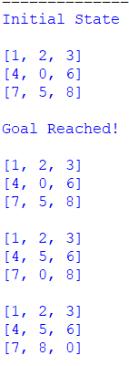

2.WRITE A PYTHON PROGRAM FOR 8-QUEENS PROBLEM.
N = 8

board = [[0 for _ in range(N)] for _ in range(N)]

def isSafe(board, row, col):

# Check left side
for i in range(col):
if board[row][i] == 1:
return False

# Check upper-left diagonal
i = row
j = col
while i >= 0 and j >= 0:
if board[i][j] == 1:
return False
i -= 1
j -= 1

# Check lower-left diagonal
i = row
j = col
while i < N and j >= 0:
if board[i][j] == 1:
return False
i += 1
j -= 1

return True

def solve(board, col):

if col >= N:
return True

for row in range(N):

if isSafe(board, row, col):

board[row][col] = 1

if solve(board, col + 1):
return True

board[row][col] = 0

return False

if solve(board, 0):

print("Solution Found:\n")

for row in board:
print(row)

else:
print("No Solution Exists")

OUTPUT:
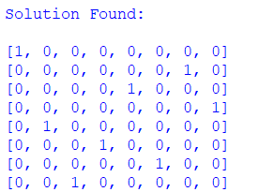

3.WRITE A PYTHON PROGRAM FOR WATER JUG PROBLEM.
from collections import deque

def water_jug(jug1, jug2, target):

visited = set()
queue = deque()

queue.append(((0, 0), []))

while queue:

(x, y), path = queue.popleft()

if (x, y) in visited:
continue

visited.add((x, y))
path = path + [(x, y)]

if x == target or y == target:
print("Solution Found!\n")
for step in path:
print(step)
return

next_states = [

(jug1, y), # Fill Jug1
(x, jug2), # Fill Jug2
(0, y), # Empty Jug1
(x, 0), # Empty Jug2

(x - min(x, jug2 - y),
y + min(x, jug2 - y)), # Jug1 -> Jug2

(x + min(y, jug1 - x),
y - min(y, jug1 - x)) # Jug2 -> Jug1
]

for state in next_states:
if state not in visited:
queue.append((state, path))

print("No Solution Exists")

jug1 = 4
jug2 = 3
target = 2

water_jug(jug1, jug2, target)

OUTPUT:
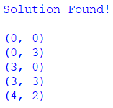

4.WRITE A PYTHON PROGRAM FOR CRIPT-ARITHMETIC PROBLEM
from itertools import permutations

letters = ('S', 'E', 'N', 'D', 'M', 'O', 'R', 'Y')

digits = range(10)

for p in permutations(digits, len(letters)):

S, E, N, D, M, O, R, Y = p

# Leading letters cannot be zero
if S == 0 or M == 0:
continue

SEND = S*1000 + E*100 + N*10 + D
MORE = M*1000 + O*100 + R*10 + E
MONEY = M*10000 + O*1000 + N*100 + E*10 + Y

if SEND + MORE == MONEY:

print("Solution Found!\n")

print("SEND =", SEND)
print("MORE =", MORE)
print("MONEY =", MONEY)

print("\nLetter Assignments:")
print("S =", S)
print("E =", E)
print("N =", N)
print("D =", D)
print("M =", M)
print("O =", O)
print("R =", R)
print("Y =", Y)

break

OUTPUT:
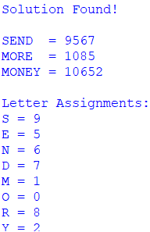

5.WRITE A PYTHON PROGRAM FOR MISSIONARIES CANNIBAL PROBLEM.
from collections import deque

def is_valid(m, c):
# Check valid range
if m < 0 or c < 0 or m > 3 or c > 3:
return False

# Left bank condition
if m > 0 and m < c:
return False

# Right bank condition
mr = 3 - m
cr = 3 - c

if mr > 0 and mr < cr:
return False

return True

def bfs():

start = (3, 3, 1) # (Missionaries, Cannibals, Boat)
goal = (0, 0, 0)

moves = [
(2, 0),
(0, 2),
(1, 0),
(0, 1),
(1, 1)
]

queue = deque()
queue.append((start, [start]))

visited = set()

while queue:

state, path = queue.popleft()

if state == goal:
print("Solution Found!\n")

for step in path:
print(step)

return

if state in visited:
continue

visited.add(state)

m, c, boat = state

for dm, dc in moves:

if boat == 1:
new_state = (m - dm, c - dc, 0)
else:
new_state = (m + dm, c + dc, 1)

if is_valid(new_state[0], new_state[1]):
if new_state not in visited:
queue.append((new_state, path + [new_state]))

print("No Solution Exists")
bfs()
OUTPUT:
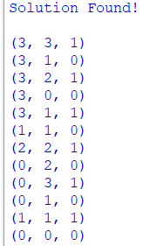

6.WRITE A PYTHON PROGRAM FOR VACCUM CLEANER PROBLEM.
# Vacuum Cleaner Problem using Simple Reflex Agent

rooms = {
"A": "Dirty",
"B": "Dirty"
}

position = "A"

print("Initial Room Status:")
print(rooms)
print()

while True:

print("Vacuum is in Room", position)

if rooms[position] == "Dirty":
print("Room", position, "is Dirty")
print("Cleaning Room", position)
rooms[position] = "Clean"

else:
print("Room", position, "is already Clean")

# Move to the other room
if position == "A":
position = "B"
else:
position = "A"

# Stop when all rooms are clean
if rooms["A"] == "Clean" and rooms["B"] == "Clean":
break

print("\nFinal Room Status:")
print(rooms)

print("\nAll rooms are Clean.")

OUTPUT:
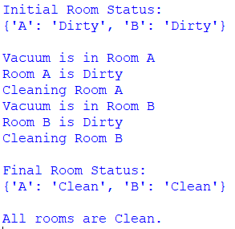

7.WRITE A PYTHON PROGRAM TO IMPLEMENT BFS.
from collections import deque

# Graph represented as an adjacency list
graph = {
'A': ['B', 'C'],
'B': ['D', 'E'],
'C': ['F'],
'D': [],
'E': ['F'],
'F': []
}

def bfs(graph, start):

visited = set()
queue = deque()

visited.add(start)
queue.append(start)

print("BFS Traversal:")

while queue:

vertex = queue.popleft()
print(vertex, end=" ")

for neighbor in graph[vertex]:

if neighbor not in visited:
visited.add(neighbor)
queue.append(neighbor)

# Starting vertex
bfs(graph, 'A')

OUTPUT:
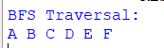

8.WRITE A PYTHON PROGRAM TO IMPLEMENT DFS.
# Depth First Search (DFS)

graph = {
'A': ['B', 'C'],
'B': ['D', 'E'],
'C': ['F'],
'D': [],
'E': ['F'],
'F': []
}

visited = set()

def dfs(node):

if node not in visited:

print(node, end=" ")

visited.add(node)

for neighbor in graph[node]:
dfs(neighbor)

print("DFS Traversal:")

dfs('A')

OUTPUT:
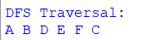

9.WRITE A PYTHON PROGRAM TO IMPLEMENT TRAVELLING SALESMAN PROBLEM.
from itertools import permutations

# Distance matrix
graph = [
[0, 10, 15, 20],
[10, 0, 35, 25],
[15, 35, 0, 30],
[20, 25, 30, 0]
]

n = len(graph)

cities = list(range(1, n))

min_cost = float('inf')
best_path = None

for path in permutations(cities):

current_cost = 0
current_city = 0

# Calculate cost of the path
for city in path:
current_cost += graph[current_city][city]
current_city = city

# Return to starting city
current_cost += graph[current_city][0]

if current_cost < min_cost:
min_cost = current_cost
best_path = (0,) + path + (0,)

print("Minimum Cost:", min_cost)

print("Best Path:")

for city in best_path:
print(city, end=" ")

OUTPUT:
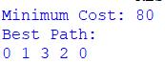

10.WRITE A PYTHON PROGRAM TO IMPLEMENT A* ALGORITHM.
import heapq

# Graph represented as adjacency list
graph = {
'A': [('B', 1), ('C', 3)],
'B': [('D', 3), ('E', 6)],
'C': [('F', 5)],
'D': [('G', 4)],
'E': [('G', 2)],
'F': [('G', 2)],
'G': []
}

# Heuristic values
heuristic = {
'A': 7,
'B': 6,
'C': 4,
'D': 4,
'E': 2,
'F': 1,
'G': 0
}

def astar(start, goal):

priority_queue = []
heapq.heappush(priority_queue, (heuristic[start], 0, start, [start]))

visited = set()

while priority_queue:

f, g, node, path = heapq.heappop(priority_queue)

if node == goal:
print("Goal Reached!")
print("Path:", " -> ".join(path))
print("Total Cost:", g)
return

if node in visited:
continue

visited.add(node)

for neighbor, cost in graph[node]:

if neighbor not in visited:

new_g = g + cost
new_f = new_g + heuristic[neighbor]

heapq.heappush(
priority_queue,
(new_f, new_g, neighbor, path + [neighbor])
)

print("No Path Found")

astar('A', 'G')

OUTPUT:
